**Machine Learning** is the Science & Art of Programming Computers so they can learn from data.

**OR**

**Field of study** that gives computer the ability to Learn without being explicitly programmed

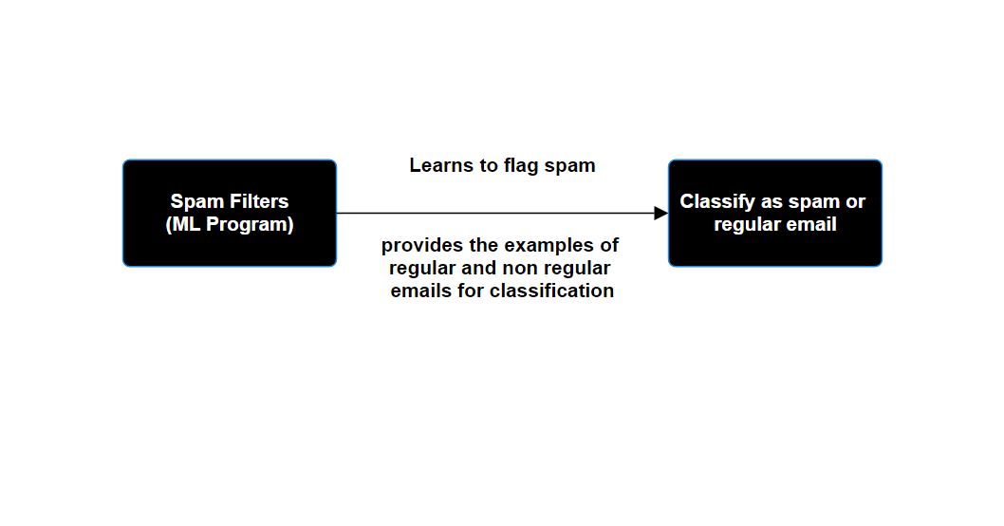

Examples that system uses to learn are called as **training sets.**

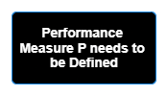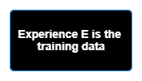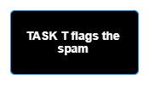

This particular performance measure is nothing but **accuracy**

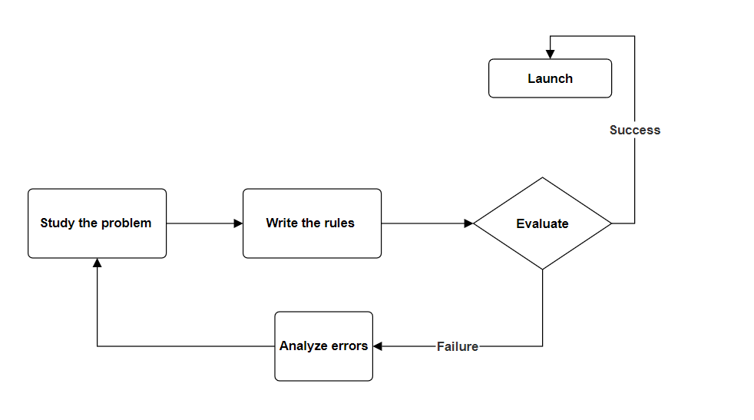

**TRADITIONAL APPROACH**

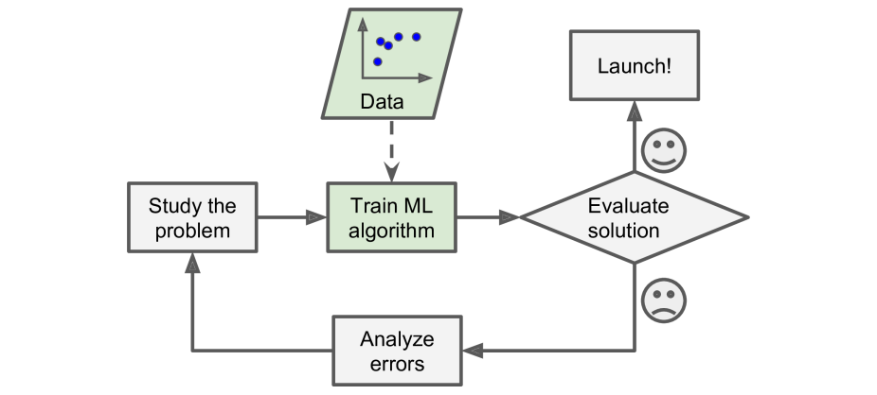

**ML APPROACH**

**Supervised Learning Algorithms**

In supervised learning algorithms, the training data we feed to the algorithm includes the desired solutions called **labels**

Typically, supervised learning task is **CLASSIFICATION**

**Regression** – it is a supervised learning-based concept where the goal is to predict a continuous numerical output based on I/P Features

Its like fitting a MATHEMATICAL MODEL TO A SET OF DATA POINTS, WHERE YOU’RE TRYING TO FIND THE BEST FITTING LINE OR THE CURVE

1. let’s say, we have some input.
2. we have some output as well.
3. Now, we gather a bunch of data where we know I/P and O/P, & we use them to teach the computer regarding how to predict the O/P based on the input. THIS IS REGRESSION.

**Advantages of Machine Learning:**

1. **Automation and Efficiency:**
   * ML helps automate repetitive tasks, making processes faster and more efficient.
2. **Accurate Predictions:**
   * ML models can make predictions or decisions based on patterns and data, often with high accuracy.
3. **Adaptability:**
   * ML models can adapt and improve as they receive new data, enhancing performance over time.
4. **Insight Discovery:**
   * ML can find valuable insights and trends in data that may not be apparent to humans.
5. **Wide Applications:**
   * ML is used in various fields like healthcare, finance, marketing, and more, solving diverse problems.

**Disadvantages of Machine Learning:**

1. **Data Dependency:**
   * ML heavily relies on quality data. If the data is biased or inaccurate, it can lead to biased predictions.
2. **Overfitting:**
   * Sometimes, ML models can become overly specialized to the training data, performing poorly on new, unseen data.
3. **Resource Intensive:**
   * Training complex ML models can require significant computing power, time, and resources.
4. **Interpretability:**
   * Some ML models are complex and challenging to understand, making it difficult to explain their decisions.
5. **Privacy Concerns:**
   * ML often deals with personal data, raising concerns about privacy and data security.

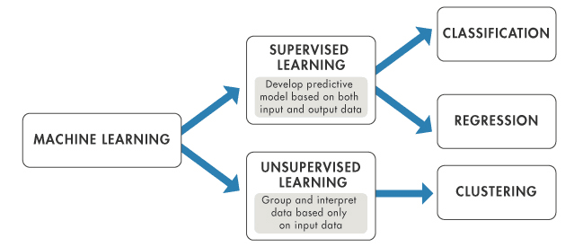

ML is classified as

1. Supervised
2. Unsupervised
3. Reinforcement
4. Semi-Supervised